Supplementary information
Table. Aggregation of ESA CCI classes into macro-categories
Macro-category | ESA CCI classes aggregated
Forest | Tree cover, broadleaved, evergreen, closed to open (>15%); Tree cover, broadleaved, deciduous, closed to open (>15%); Tree cover, broadleaved, deciduous, closed (>40%); Tree cover, broadleaved, deciduous, open (15‐40%); Tree cover, needle leaved, evergreen, closed to open (>15%); Tree cover, needle leaved, evergreen, closed (>40%); Tree cover, needle leaved, evergreen, open (15‐40%); Tree cover, needle leaved, deciduous, closed to open (>15%); Tree cover, needle leaved, deciduous, closed (>40%); Tree cover, needle leaved, deciduous, open (15‐40%); Tree cover, mixed leaf type (broadleaved and needle leaved); Mosaic tree and shrub (>50%) / herbaceous cover (<50%)
Shrub | Mosaic herbaceous cover (>50%) / tree and shrub (<50%); Scrubland; Evergreen shrub land; Deciduous shrub land
Urban | Urban areas; Bare areas; Consolidated bare areas; Unconsolidated bare areas
Crop | Cropland, rain-fed; Herbaceous cover; Tree or shrub cover; Cropland, irrigated or post‐flooding; Mosaic cropland (>50%) / natural vegetation (tree, shrub, herbaceous cover) (<50%); Mosaic natural vegetation (tree, shrub, herbaceous cover) (>50%) / cropland (<50%)
Water | Water bodies
Other | Grassland; Lichens and mosses; Sparse vegetation (tree, shrub, herbaceous cover) (<15%); Sparse tree (<15%); Sparse shrub (<15%); Sparse herbaceous cover (<15%); Tree cover, flooded, fresh or brackish water; Tree cover, flooded, saline water; Shrub or herbaceous cover, flooded, fresh/saline/brackish water; and Permanent snow and ice

Table. Distribution of land cover and socio-demographic factors
Factors | Min | Max | Median | Mean | Provinces with higher values
Land cover (Km²)
Forest | 0 | 193,958 | 8,234 | 15,072 | Vidzeme, and Kurzeve (LV), and Lõuna-Eesti (EE)
Shrub |  | 35,132 | 9 | 829 | Argolis, Arcadia and Laconia, Messenia (GR), and Almeria (ES)
Urban |  | 16,263 | 1,268 | 1,851 | Valais, and Graubünden (CH), and Cyprus (CY)
Crop | 1 | 207,653 | 13,720 | 23,524 | Badajoz, Ciudad Real, and Zaragoza (ES)
Water | 0 | 39,255 | 184 | 574 | Lõuna-Eesti (EE), Flevoland (NL), and Tulcea (RO)
Socio-demographic
GDP (Euro/person) | 2,567 | 163,117 | 25,500 | 26,441 | Basel and Zug (CH), and Wolfsburg (DE)
2-Digits ISO Codes legend: CH = Switzerland, CY = Cyprus, DE = Germany, EE = Estonia, ES = Spain, GR = Greece, LV = Latvia, NL = The Netherlands, RO = Romania

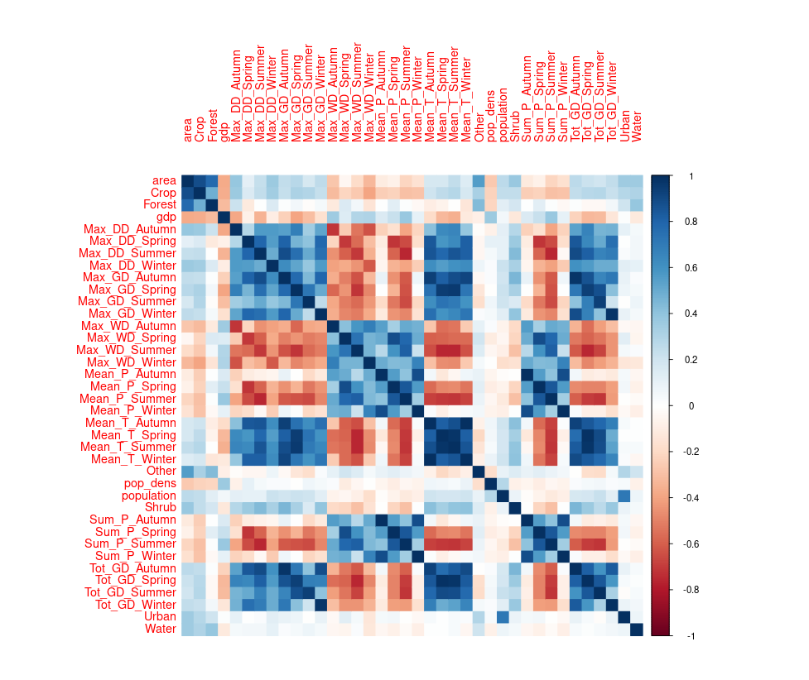
Figure S1. Correlation matrix

Table S2. Moran’s I to assess spatial autocorrelation of the variables considered for the geographically-weighted regression model. Standard deviations from expected value (Std. dev.) and p-values (p) are provided.
Variable | I | Std. dev. | Variance | p
Incidence | 0.12824471 | 21 | 0.00003624 | <.001
Land Cover
Forest | 0.28049834 | 44 | 0.00004108 | <.001
Shrub | 0.14017861 | 22 | 0.00003987 | <.001
Urban | 0.19674706 | 31 | 0.00004127 | <.001
Crop | 0.37845248 | 59 | 0.00004153 | <.001
Water | 0.07458688 | 13 | 0.00003154 | <.001
Other | 0.18988389 | 30 | 0.00004123 | <.001
Climatic variables
Mean_P_Winter | 0.31227906 | 49 | 0.00004155 | <.001
Max_WD_Winter | 0.38121530 | 59 | 0.00004171 | <.001
Max_DD_Winter | 0.32250407 | 50 | 0.00004157 | <.001
Mean_T_Spring | 0.34374199 | 53 | 0.00004168 | <.001
Max_DD_Spring | 0.23726303 | 37 | 0.00004154 | <.001
Max_WD_Autumn | 0.45323882 | 70 | 0.00004172 | <.001
Max_DD_Autumn | 0.50463685 | 78 | 0.00004167 | <.001
Socio-demographic
GDP | 0.45385101 | 71 | 0.00004138 | <.001
Population density | 0.05602138 | 9 | 0.00003715 | <.001

Table S3. Variance inflation factors (VIFs) considered as evaluation of potential presence of multicollinearity in the sample. Value rage considered: <1 (No multicollinearity), 1-5 (Minimal-to-Moderate multicollinearity), 5-10 (Moderate-to-Severe multicollinearity), >10 (Severe multicollinearity).
Land Cover |  |  |  |  | Climatic Variables |  |  |  |  |  |  |  |  |  | Socio-demo
Forest | Shrub | Urban | Crop | Water |  | Other | Mean P Win | Max WD Win | Max DD Win | Mean T Spr | Max DD Spr | Max WD Aut | Max DD Aut | GDP |  | Pop Dens
1.93 | 1.31 | 1.20 | 1.91 | 1.24 |  | 1.50 | 2.63 | 4.52 | 2.79 | 3.36 | 2.19 | 3.01 | 3.26 | 1.71 |  | 1.28

